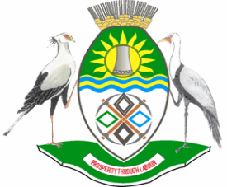

NKANGALA DISTRICT MUNICIPALITY

PUBLIC NOTICE

INVITATION TO THE NKANGALA DISTRICT IDP/BUDGET INDABA 2021/2021

In terms of S30 of the Municipal Systems Act (MSA), the Executive Committee or the Executive Mayor of a municipality must, inter alia, in accordance with S29 of the MSA, submit the draft IDP to the Municipal Council for adoption by the Council. In terms of section 23 (1) of the Municipal Finance Management Act (MFMA), the council must consider the views of the community on the tabled budget.

The Nkangala District Municipality is in the process of finalizing its Draft IDP for the 2021/2022 financial year and will table the draft budget in the council of 31 March 2021. Subsequent to consultation processes with the communities within the District, an IDP/BUDGET INDABA will be held on the 8th-9th of April 2021. The final IDP will then be tabled to Council for approval on the 26th May 2021 and the final Budget will be tabled in council on the 26th May 2021 for final approval. Therefore, the Honourable Executive Mayor, Cllr TS Masilela, of Nkangala District Municipality (NDM) is inviting you as a key stakeholder to be part of this process.

The schedule of the meeting is as follows:

VENUE : VIRTUALLY ON MICROSOFT TEAMS & SOCIAL MEDIA
DATE : 8-9 APRIL 2020
TIME : 10H00

To receive the link contact Ms Sbongile Mtsweni @ email: mtswenisl@nkangaladm.gov.za or thwalaan@nkangaladm.gov.za on or before the 6th of April 2021.

MM SKOSANA
MUNICIPAL MANAGER

